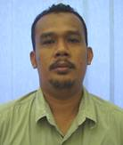
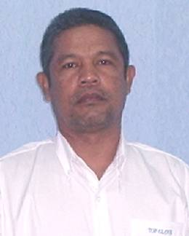

TOP GLOVE SDN BHD (220483-T)
DRIVER REQUEST FORM (DRF)
Rosman
012-3059759

Mukhtar 019-9438410

Philipson
010-3670305

Date Submitted DRF :_______________

From (OIC) :______________________ Mobile No. : _______________________
Date Required Picking up Customer: _______________ Time of Picking up : ______ AM/PM
Customer’s Information
Name of Customer :____________________ Company : _________________________
Customer’s Mobile No.____________________ Country of Origin : ______________________
No. of pax Existing Customer Potential Customer
Pick up customer from :
A ) Airport LCCT / KLIA
Flight Arrival Time :________ AM / PM Flight No : _________ Flight is From : ________________

Yellow placecard enclosed (YES / NO)
B) Hotel
___________________________________________________________________________________________________
(Please provide the full address of the Hotel)
Hotel Tel. :________________ Room No. _______
C) Others ___________________________________________________________
(Please specify the exact location)
After picking up customer, send customer to : ________________________________________

Special instructions: Please Tick √ if required
1. To call the OIC upon reaching Setia Alam Toll.
2. If the venue is at F18, to call the OIC upon exiting the LCCT, left turning.
3. To send the customer back after meeting.
4. To send the customer to visit another supplier.
5. Others – please specify _________________

● Note to marketer: Please call the driver if there is any change of pick up immediately once you have the
confirmation from the customer. Or else, a training letter with fine will be issued to the respective officer.

Driver to assess. Yes No
1. Did the marketer provide the hotel room number before the pick up?
2. Upon arrival to F9, did the marketer wait at the reception lobby to welcome the customer?

● Note to driver: Please call the marketer’s handphone if pick up arrangement is on Sunday or during
public holidays to confirm the pickup.

Ref: lkm/cina/aug10 (updated : 4/11/11)

